ONLINE MARKETING CONCEPT
Pick Any Two Apps and Identify One Online Marketing Technique
App 1: Zomato
Online Marketing Technique: Referral Marketing
Zomato uses referral marketing to attract new users by offering referral rewards. Existing users can invite friends using a referral code, and both users receive discounts or cashback after the first successful order.
App 2: Flipkart
Online Marketing Technique: Personalized Email Marketing
Flipkart attracts new users and engages existing customers through personalized email campaigns and app notifications. It sends product recommendations, exclusive discounts, and festival sale updates based on users' interests and shopping behaviour, encouraging them to visit the app and make purchases.
2.Create a simple digital flyer

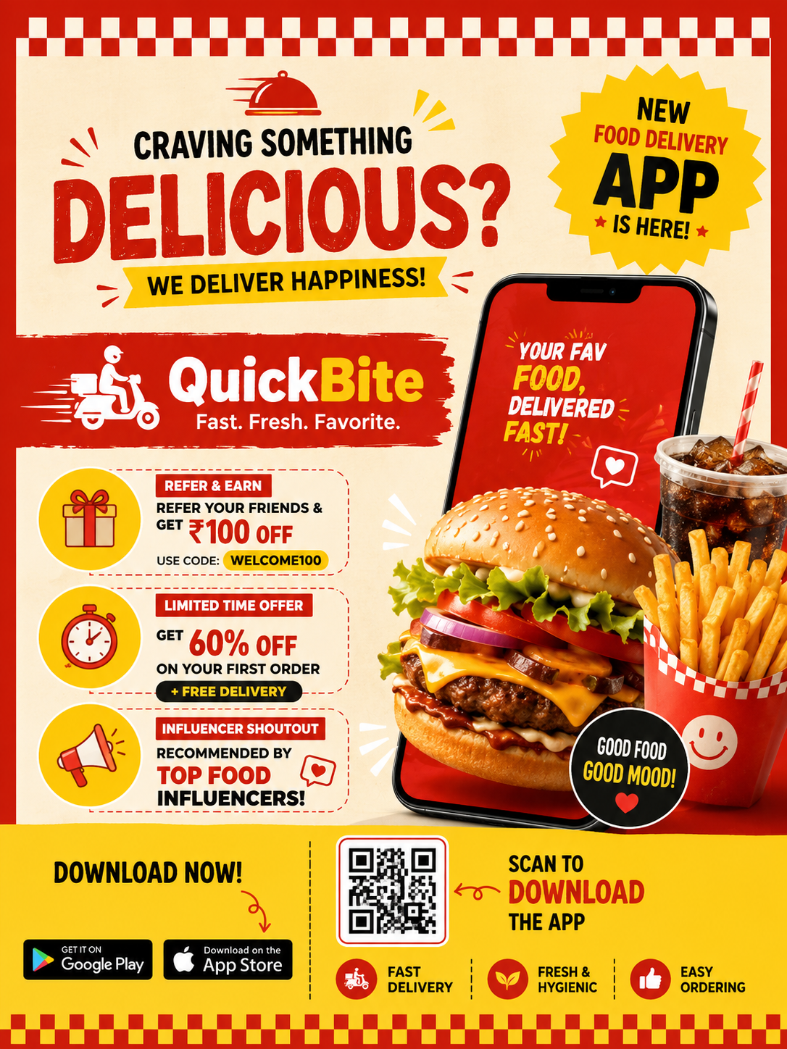
3. Five Types of Online Advertisements I Have Seen
1. Skippable Video Advertisement
- Platform: YouTube
- Why it stands out: These ads appear before or during a video and can usually be skipped after five seconds. They often use interesting stories or catchy music to keep viewers watching.
2. Sponsored Feed Advertisement
- Platform: Instagram
- Why it stands out: These ads appear while scrolling through the feed and look similar to normal posts. High-quality images, discounts, and engaging captions make them attractive.
3. Story Advertisement
- Platform: Instagram
- Why it stands out: Story ads fill the entire mobile screen with videos or animations. Users can quickly swipe to skip them, but eye-catching visuals make many people stop and watch.
4. Search Advertisement
- Platform: Google
- Why it stands out: These ads appear at the top of search results when searching for products or services. They are useful because they match exactly what users are looking for.
5. In-App Promotional Advertisement
- Platform: Facebook
- Why it stands out: These ads promote products, services, or events with images, videos, and "Shop Now" or "Learn More" buttons, making them easy to interact with.

4. Marketing Plan for a New Playlist Feature in a Music App
To introduce the new playlist feature, I would first improve the website using SEO so people searching for playlist-related topics can easily discover it. Then, I would post creative reels, short videos, and graphics on Instagram, Facebook, and X to create excitement. An email campaign would be sent to existing users with personalized recommendations and a direct link to try the feature. I would also collaborate with music influencers and content creators to showcase how the playlist feature enhances the listening experience. Finally, I would encourage users to share their own playlists on social media using a unique hashtag to increase engagement and attract new users.

